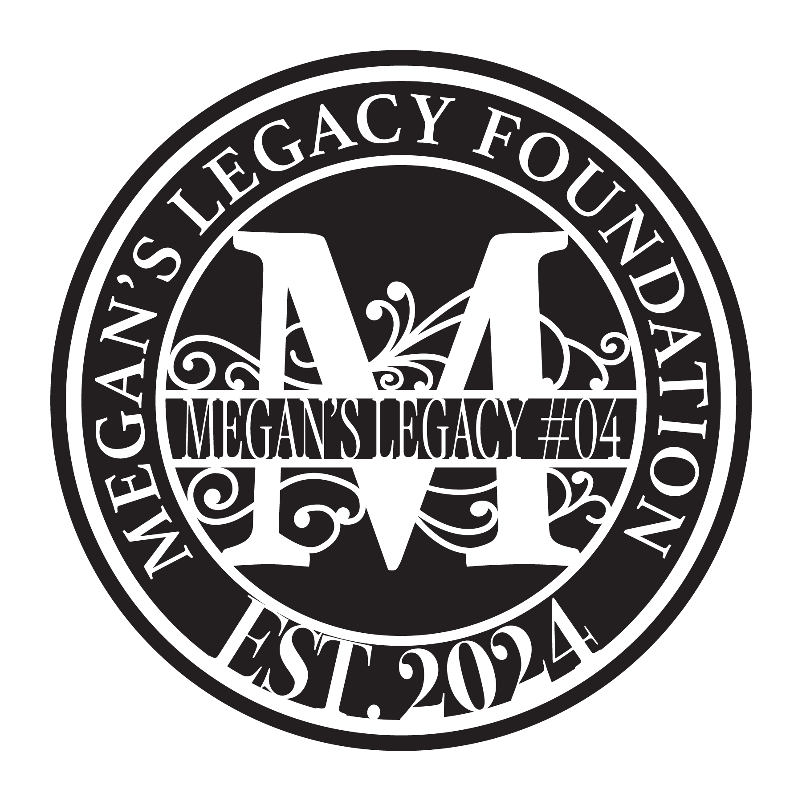

**For Off Road Safety Awareness**

**a *501(c)3 Non-Profit Foundation***

**Subject:** Support Needed for Off-Road Safety Awareness – Megan’s Legacy Foundation

Dear OHV Community Member,

My name is Jennifer Woodworth-Whitney, and I am reaching out on behalf of the Megan’s Legacy Foundation, a registered 501(c)(3) nonprofit. Since 2022, we have been dedicated to promoting off-road safety and education in memory of Megan Marie Lopez, who tragically lost her life on January 29, 2022, in the Ocotillo Wells SVRA. Our mission is to create life-saving safety awareness within the Off-Highway Vehicle (OHV) community.

We are currently organizing our **4th Annual Megan’s Legacy Memorial Ride**, which will be held on **October 25, 2025**. This event brings together our community to raise awareness for OHV safety. We anticipate over 300 attendees and will be hosting an **opportunity drawing and silent auction** as part of our fundraising efforts.

We are seeking donations of safety gear, in-kind items, or monetary gifts to support our cause. Your generosity would make a meaningful difference, and in appreciation, we will:

* Provide a tax-deductible donation letter
* Acknowledge your business on event signage and our website
* Thank you during our safety presentation
* Feature your support in our annual KUSI News segment

Would you be willing to support our efforts with a donation?

To learn more or to get involved, please visit our website: [www.meganslegacyfoundation.org](http://www.meganslegacyfoundation.com). If you have any questions or would like to begin this partnership, don’t hesitate to reach out.

On behalf of Megan’s family and the Foundation Board, thank you for your time and consideration.

Warm regards,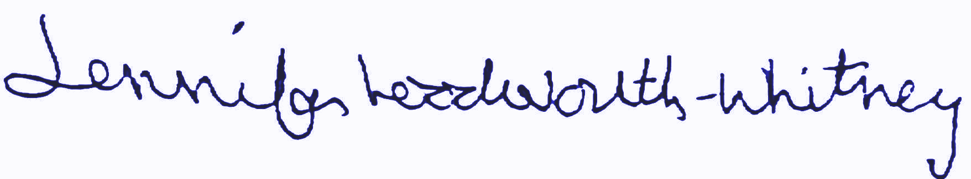

Jennifer Woodworth-Whitney

Megan’s Legacy Foundation

[Jenniferww@meganslegacyfoundation.org](mailto:Jenniferww@meganslegacyfoundation.com)

Ph: 760-650-2012